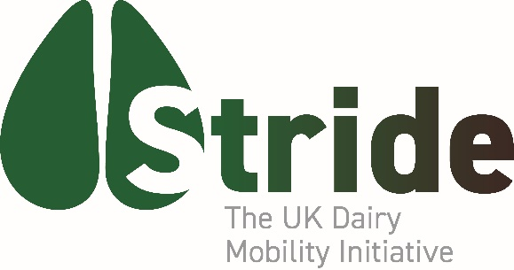

SECOND NATIONAL MOBILITY SURVEY LAUNCHED

The Stride national dairy mobility initiative has launched its second national survey to better understand the hoof health challenges faced by UK herds. Anyone completing the survey will be entered into a draw to win one of five pairs of Apple AirPods.

The results will help to develop practical strategies to reduce the consequences of compromised mobility and poor hoof health.

Founded in 2024, Stride is a not-for-profit initiative established to challenge the status quo on lameness. Its objectives are to increase understanding of the issues surrounding dairy cow mobility, to contribute to industry knowledge, and help develop clear management strategies that deliver sustained improvement in foot health. The partners in Stride are Ceva, HerdVision, Hoofcount, Kersia, IVC Farm Vets, Neogen, NoBACZ Healthcare and Teemore Engineering.

“Mobility issues remain a major drain on dairy performance and profitability, and it is time for an increasingly practical and pragmatic approach,” comments dairy vet Matt Dobbs, chair of the Stride Technical Board.

“Reduced mobility and compromised hoof health remain endemic problems affecting around 30% of cows and are a major cause of premature culling. These incidences have hardly changed during the past 30 years. Poor mobility costs the dairy sector an estimated £250m per year through impaired fertility, reduced production, premature culls, and treatment costs.”

Yet Mr Dobbs says there have been significant advances in the understanding of the causes of lameness, the management strategies to prevent problems and the range of effective treatments that, together, offer the potential to reduce the incidence and consequences of poor foot heath.

“On all farms, the crucial question is: what can be done differently or better to help reduce mobility problems? In the 2026 survey, launched at Dairy-Tech, we want to try and understand more about why mobility is remaining such a stubborn nut to crack. What are the reasons it is not given a higher priority and what needs to be done to increase the focus on mobility and hoof health?

“We hope farmers will be prepared to spend a few minutes completing the online survey so we can continue to build the most comprehensive picture of UK dairy cow mobility and develop meaningful actions to raise mobility levels across the national herd,” Mr Dobbs continues.

The survey will run until April 30, 2026. To complete the survey scan the QR code or go to: https://www.stridemobility.co.uk/. All respondents will be entered in a draw to win one of five pairs of Apple AirPods.
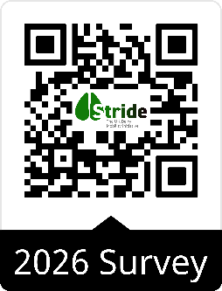
-ends-
Date: 4 February 2026
For more information: Matthew Dobbs 07712-576609matt.dobbs@agsenze.com Issued by: Phil Eades Mardle Consulting 07939-597981
Note: Matthew Dobbs will be on the Stride stand at DairyTech (Hall 3 P156)

